4.54: The velocity as a function of time is 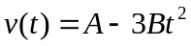 and the acceleration as a function of time is 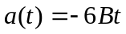, and so the Force as a function of time is 

